Summary

The BitTorious network uses the BitTorrent protocol to facilitate the distribution of large datasets. Before publishing data, the publisher will need to establish a BitTorrious account as well as a Linux user account on torrent-tgen – the dedicated TGen client.

Creating a BitTorious Account

From any computer, open a browser and navigate to <http://dell.bittorious.com>, then click “Request Account” in the upper right-hand corner.

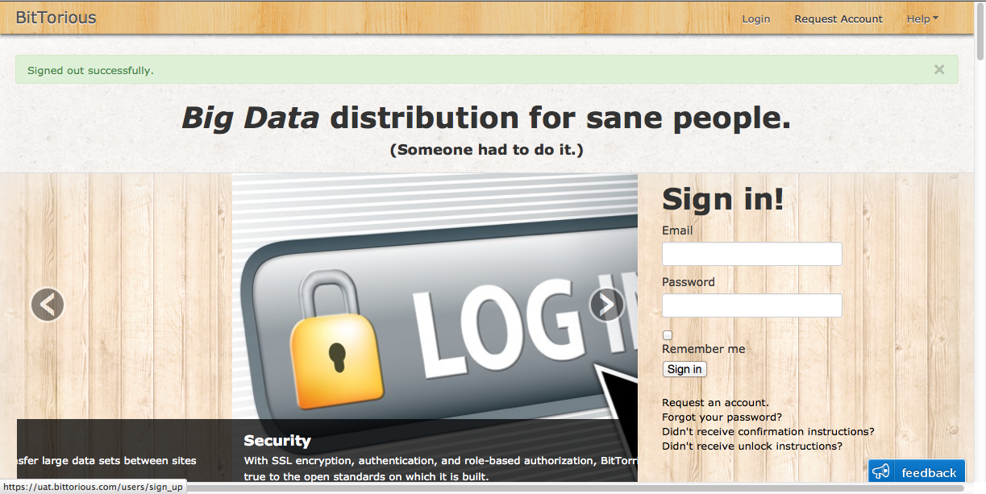

Fill in your email and password information (the minimum password length is six characters), then click the “Sign up” button. Once an administrator has reviewed and approved your account a confirmation will be sent to the email address with which you registered.

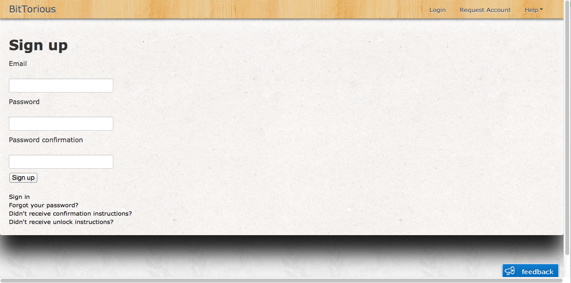

Publishing Data

Publishing data to BitTorrious requires the creation of a torrent file, uploading the torrent file to the BitTorrious portal, then loading an edited version of the torrent file into your bittorrent client.

Creating a Torrent file

These steps must be run from a computer that has X-Windows.

1. Start the “X” session
2. Open an xterm
3. Type **xhost +** in the xterm window. This will allow torrent-tgen to display applications on your local computer’s display.
4. Type **ssh –X torrent-tgen** in the xterm window. You will be prompted for your torrent-tgen Linux user credentials.
5. Once login is successful, start qBitTorrent by typing **qbittorrent&** in the xterm window.
6. From the “Tools” drop-down menu on the qBitTorrent interface, select “Torrent Creator”. 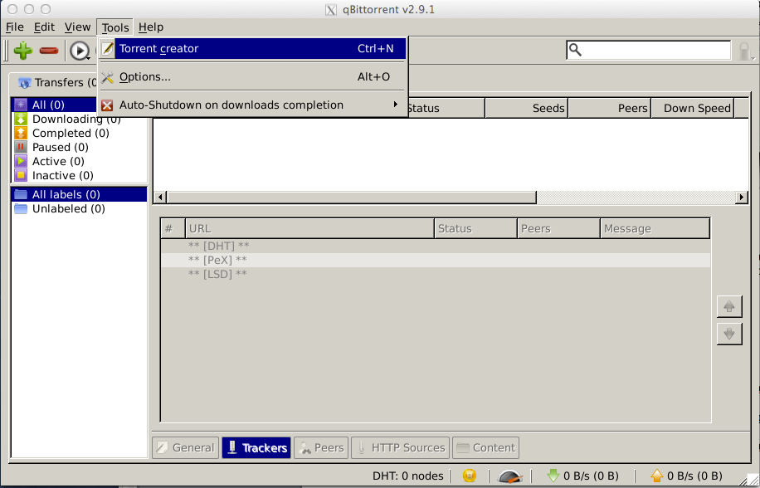
7. Click “Add File” and navigate to the data file you wish to publish. Do not select any other option in this window. Choose a name for the torrent file, then click “Create and save”. 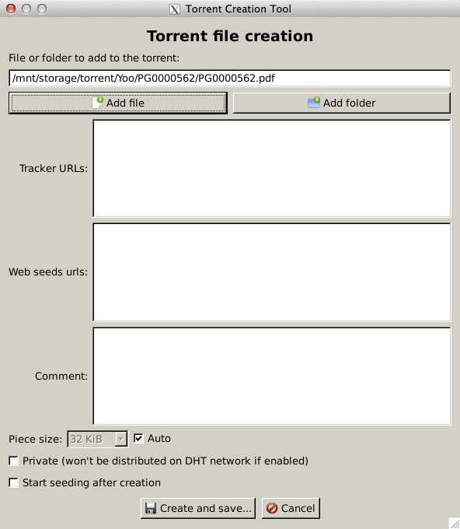
8. In the xterm window, start the Firefox browser by typing **firefox&**
9. Using the browser window from the previous step, navigate to <http://dell.bittorious.com> and login using your BitTorious credentials, then select “Dashboard” from the top navigation bar. The dashboard will present you with a list of feeds.
10. If you wish to create a new feed, click the “Create a feed” button on the bottom of the feeds list; otherwise, select an existing feed to which you will publish your torrent by clicking on the feed in the list. 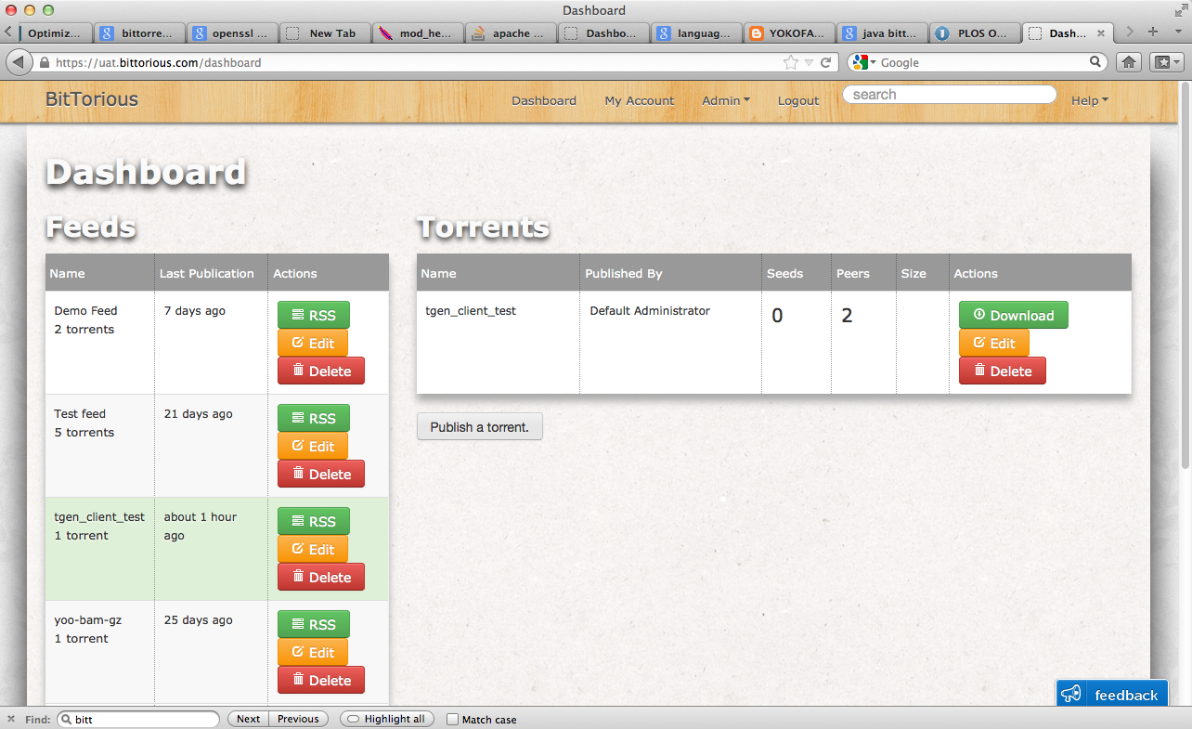
11. Once the feed is selected, click the “Publish a torrent” button and a popup window will appear. Enter a name for your torrent in the “Name” field as well as any tags in the “Tags” field that will help others find this file, then click the “Browse” button and navigate to the torrent file you created using qBitTorrent. Click the “Publish” button when finished.
12. The BitTorrious portal adds crucial information to the torrent files you upload, so you need to download this newly-created torrent from the portal and open it using qBitTorrent. To do this, select the “Download” button on the torrent you just created in the portal. You will see a dialog box asking you if you want to open this file with qBitTorrent. Click “OK”. 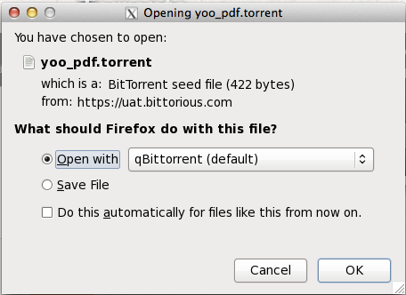
13. A new qBitTorrent window will open showing your data file. You have now published your data and others will be able to begin downloading it. 